Task 1.1:
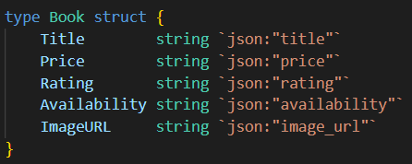
This part defines a Book struct, which holds the essential details of each book: title, price, rating, availability, and image URL.
It also makes use of JSON tags to simplify the process of serializing the data into JSON format.
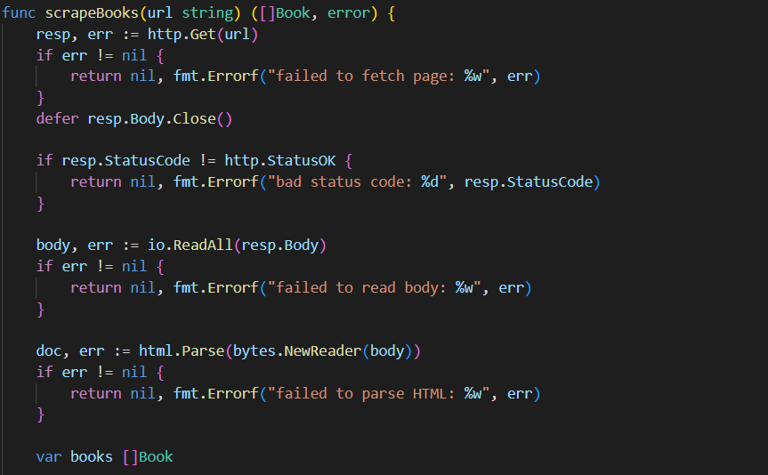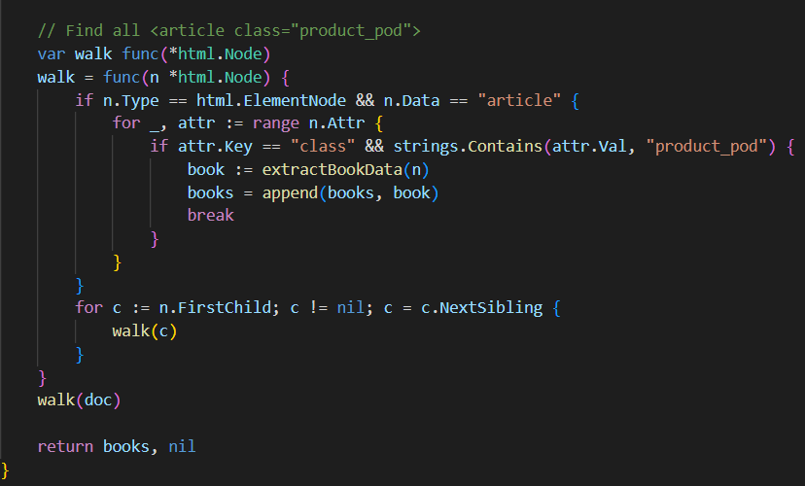
This function is responsible for gathering the book data. Here’s how it works:
- It sends an HTTP GET request to the target website URL.
- Once the page is fetched, it uses the golang.org/x/net/html package to parse the HTML content.
- The function then walks through the DOM tree, looking specifically for all <article class="product_pod"> elements. Each of these represents a single book on the page.
- Finally, it returns a slice of Book objects, each containing the extracted information for one book.

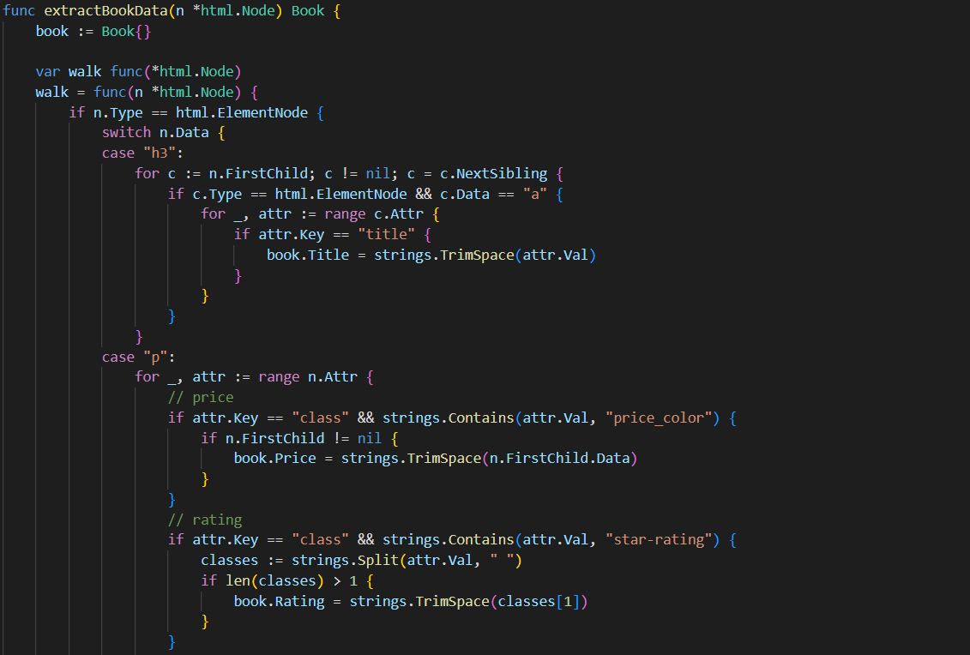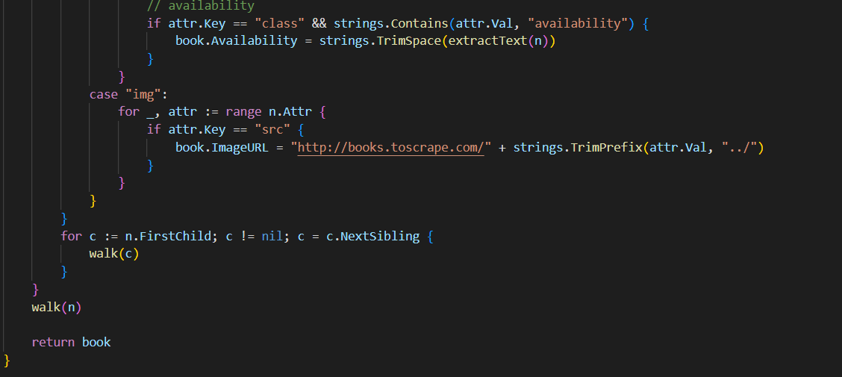
For each book article, this function pulls out the following details:
- Title: Extracted from the title attribute inside the <h3><a> tag.
- Price: Located within the <p class="price_color"> element.
- Rating: Found in the <p class="star-rating"> class (e.g., "Three", "Five", etc.).
- Availability: Taken from the <p class="availability"> element.
- Image URL: Constructed by extracting the src attribute from the <img> tag, and then prepending the base URL to form the complete link.

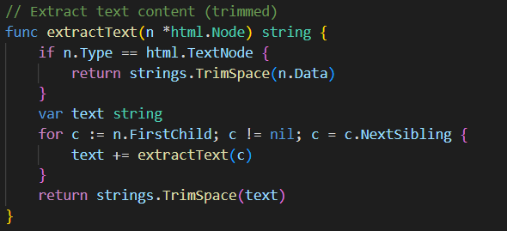
extractText(): This function recursively extracts text content from HTML nodes.

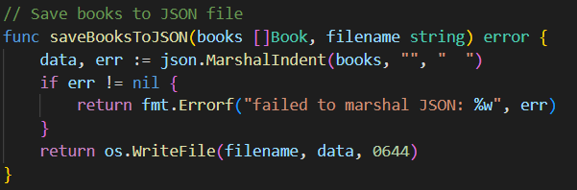
Converts price strings (e.g., "£51.77") to float64 for calculations

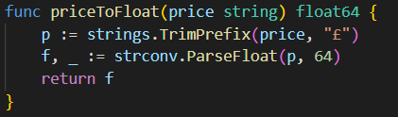
Marshals the book data to JSON format and saves to file

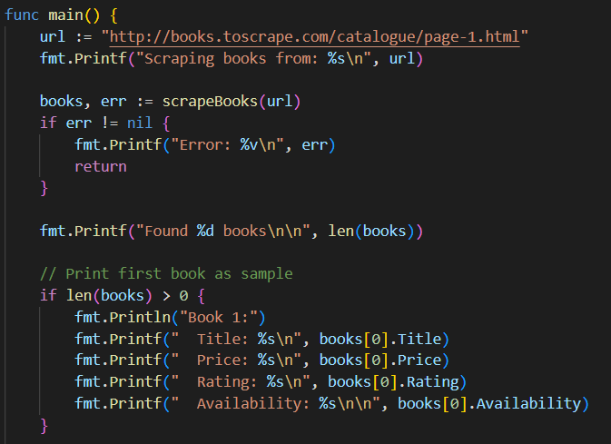
- Scrapes books from page 1
- Prints the first book as a sample
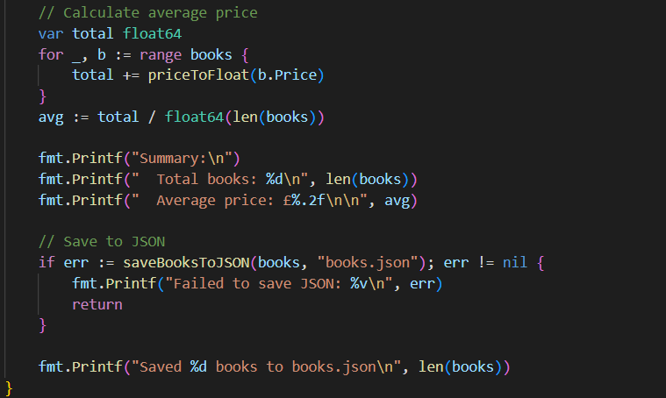
- Calculates and displays the average book price
- Saves all book data to books.json

Output:
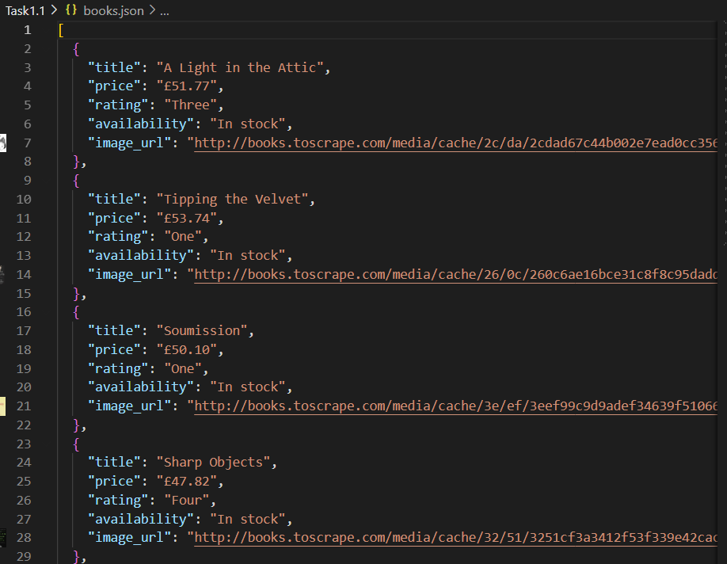

Task 2.1:
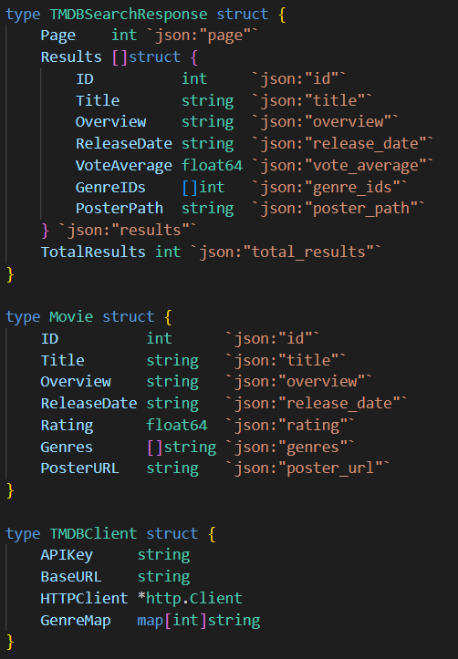
- TMDBSearchResponse: Represents the API response structure
- Movie: Custom structure to store processed movie information
- TMDBClient: Client wrapper with API key, HTTP client, and genre mapping

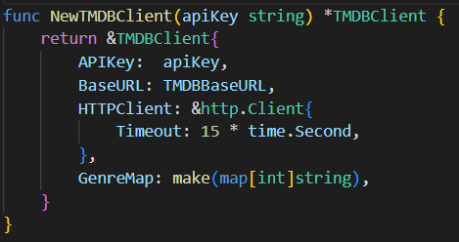
NewTMDBClient(): Constructor that initializes the client with a 15-second timeout

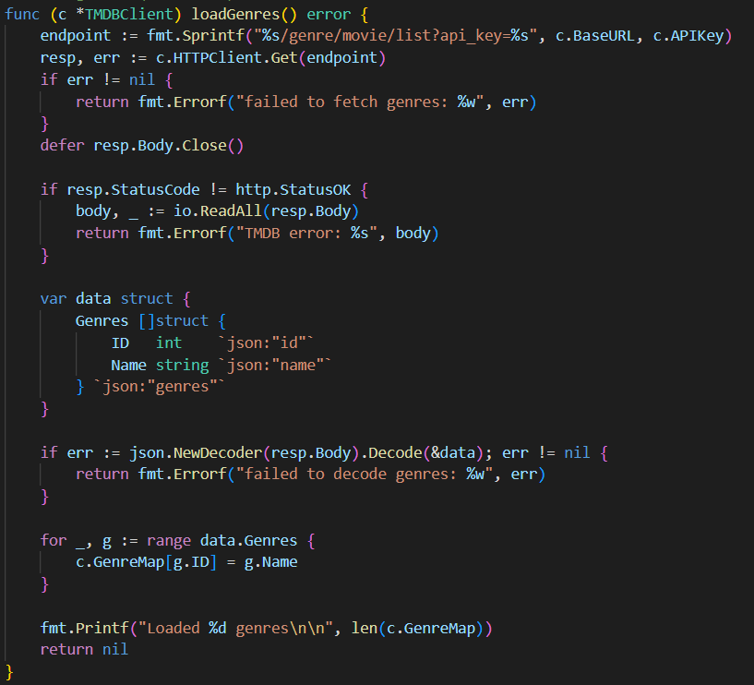
loadGenres(): Fetches the genre list from TMDB and creates a mapping from genre IDs to names

- 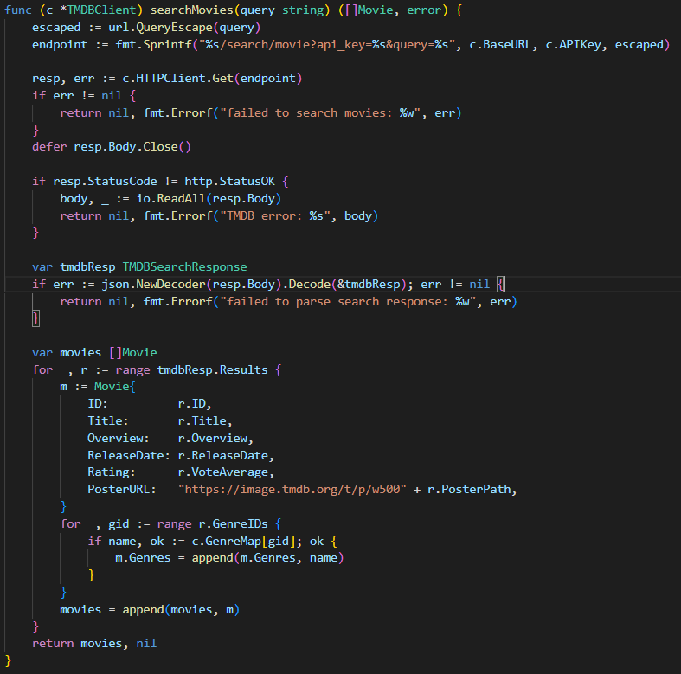 searchMovies():
  - URL-encodes the search query
  - Makes API request to the search endpoint
  - Converts TMDB response to custom Movie format
  - Maps genre IDs to genre names using the pre-loaded genre map
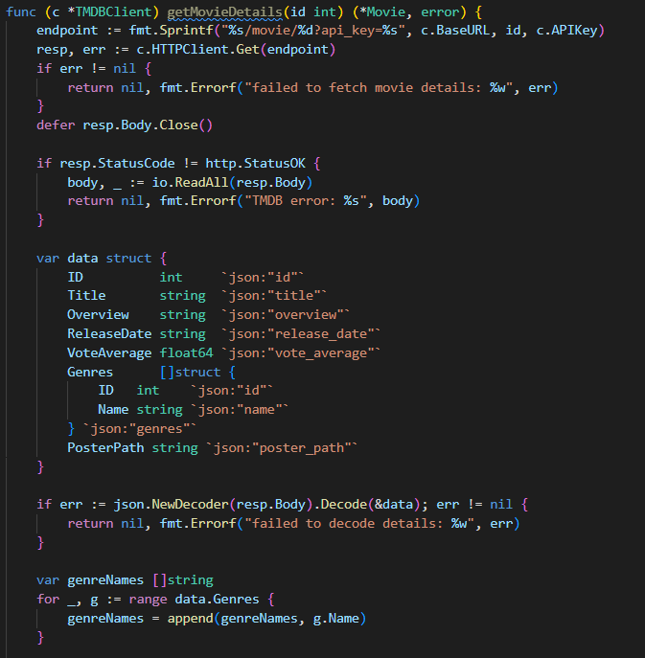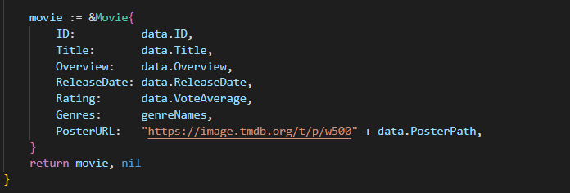
getMovieDetails(): Fetches detailed information for a specific movie by ID

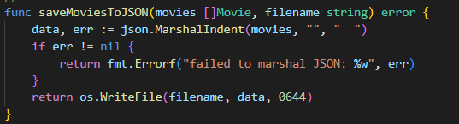
Marshals movie slice to formatted JSON

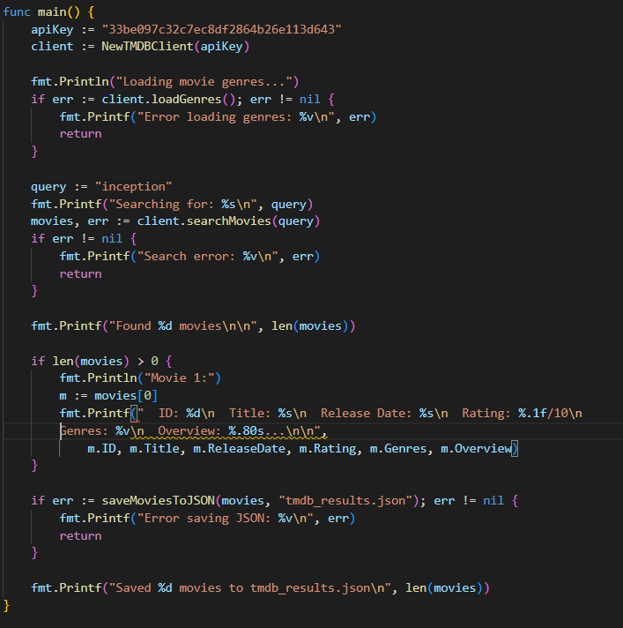
- Creates TMDB client with API key
- Loads genre mappings
- Searches for movies with query "inception"
- Displays the first movie's details
- Saves all results to tmdb_results.json
Output:
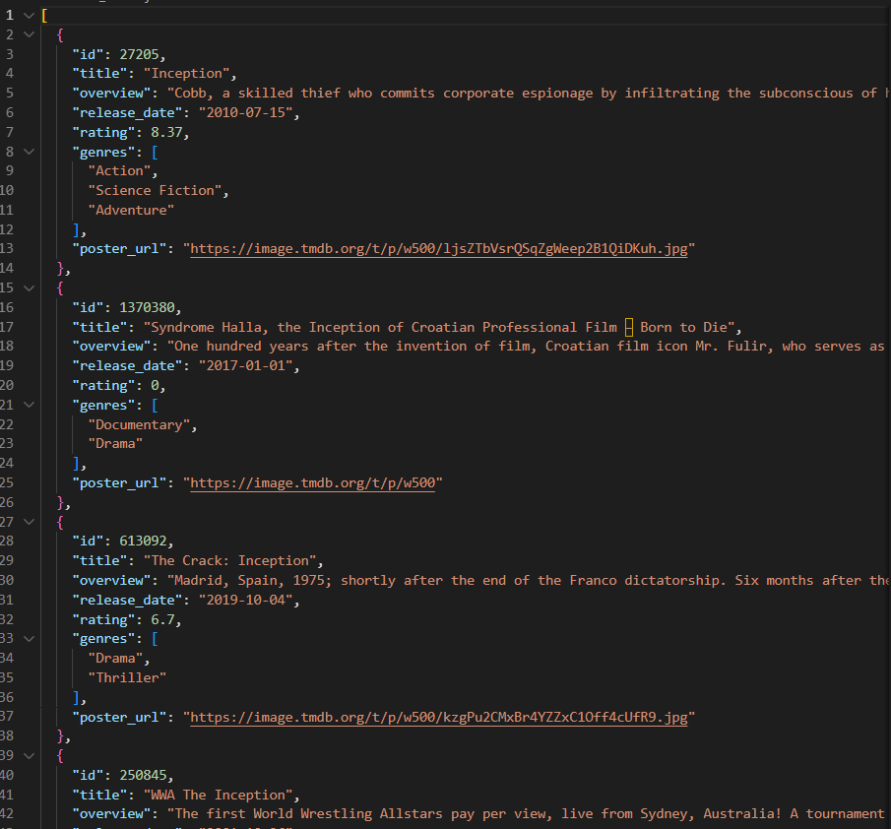

Task 2.2:
MovieInfo
- Unified movie data structure across all sources
- Fields: ID, Title, Director, Year, Description, Genres, Rating, Duration, Source, LastUpdated
- More comprehensive than the Movie struct from Task 2.1
MovieSource (interface)
- Defines contract for all movie data sources
- Methods: GetMovies(query, limit) and GetName()
TMDBSource
- Implements MovieSource for TMDB API
- Wraps the TMDBClient from previous code
- Converts Movie to MovieInfo format
MockScraperSource
- Implements MovieSource for simulated scraped data
- Returns fake movie data for testing
- Demonstrates how to add additional sources
MovieAggregator
- Combines multiple MovieSource implementations
- Orchestrates concurrent queries and result merging
Key Functions
NewTMDBSource(apiKey) *TMDBSource
- Creates TMDB source wrapper
- Initializes internal TMDB client
TMDBSource.GetMovies(query, limit) ([]MovieInfo, error)
- Loads genres if needed
- Searches TMDB using the client
- Converts results to MovieInfo format
- Extracts year from release date string
- Returns limited results
MockScraperSource.GetMovies(query, limit) ([]MovieInfo, error)
- Generates mock movie data based on query
- Returns predefined fake results for testing
- Useful for development without real scraper
NewMovieAggregator(sources...) *MovieAggregator
- Creates aggregator with variable number of sources
- Uses variadic parameter for flexibility
MovieAggregator.Search(query, limitPerSource) ([]MovieInfo, error)
- Main aggregation function
- Queries all sources concurrently using goroutines
- Each source runs in separate goroutine with go func()
- Uses sync.Mutex to protect shared allMovies slice
- Uses sync.WaitGroup to wait for all goroutines to complete
- Deduplicates results after collection
- Returns merged, deduplicated movie list
deduplicateMovies(movies) []MovieInfo
- Removes duplicate movies based on title similarity
- For each movie, finds all similar titles (≥80% similarity)
- Merges duplicate data:
  - Keeps highest rating
  - Combines all genres
  - Fills in missing director/duration
- Marks duplicates as "used" to skip them
- Sorts final results by rating (descending)
calculateSimilarity(title1, title2) float64
- Returns similarity score between two titles (0.0 to 1.0)
- Normalizes titles (lowercase, trim)
- Removes punctuation (:, -, ,)
- Calculates word overlap percentage
- Returns 0.9 if one title contains the other
- Uses word matching for similarity calculation
- Ignores short words (≤2 chars)
generateReport(movies)
- Prints comprehensive statistics:
  - Total movies found
  - Count by source
  - Top 10 genres by frequency
  - Average rating across all movies
- Sorts genres by count before displaying
saveToJSON(movies, filename) error
- Marshals movies to pretty-printed JSON
- Writes to file with 0644 permissions
- Returns formatted error if fails
main()
- Creates aggregator with TMDB + mock scraper
- Searches for "spider-man" with limit of 10 per source
- Displays top 5 deduplicated results with details
- Generates statistical report
- Saves all results to "aggregated_movies.json"

Output:
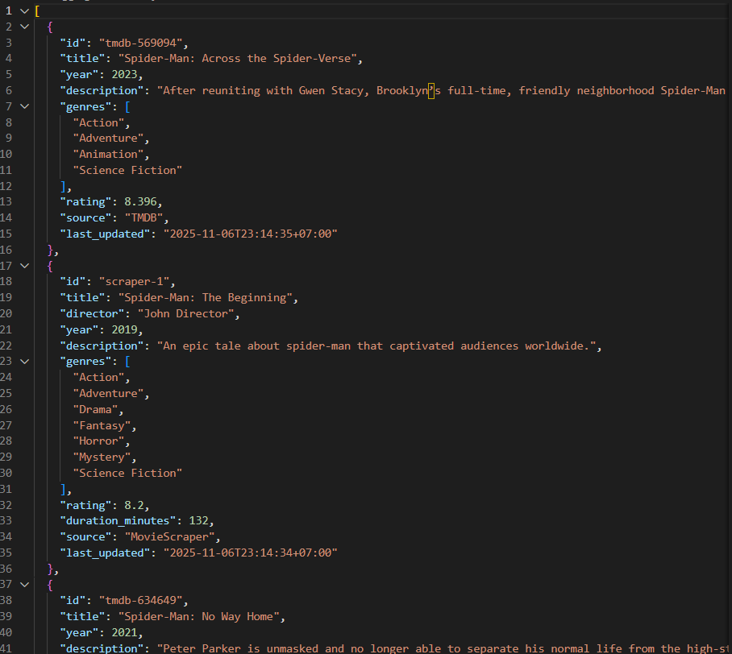

Task 3.1:
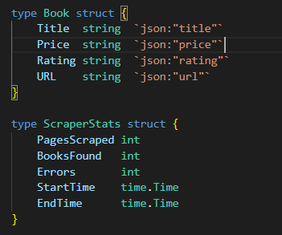
Book Structure
Represents a book with title, price, rating, and URL. JSON tags define how these fields appear when exported, making each book a simple, consistent object for storage, sharing, or processing.
ScraperStats Structure
Tracks scraping performance, including pages scraped, total books, errors, and start/end times, enabling efficiency measurement, issue detection, and result summarization.

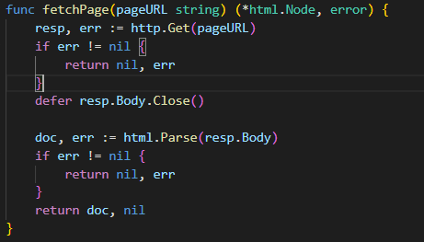
fetchPage Function
Purpose: Downloads the HTML content from a given URL and parses it into a tree structure.
How it works:
- Sends an HTTP GET request to the URL.
- Reads the response body.
- Parses the HTML into a structured node tree.
- Returns the parsed document, or an error if the HTTP request or parsing fails.
This function is the foundation of the scraper, because all further processing relies on a correctly parsed HTML document.
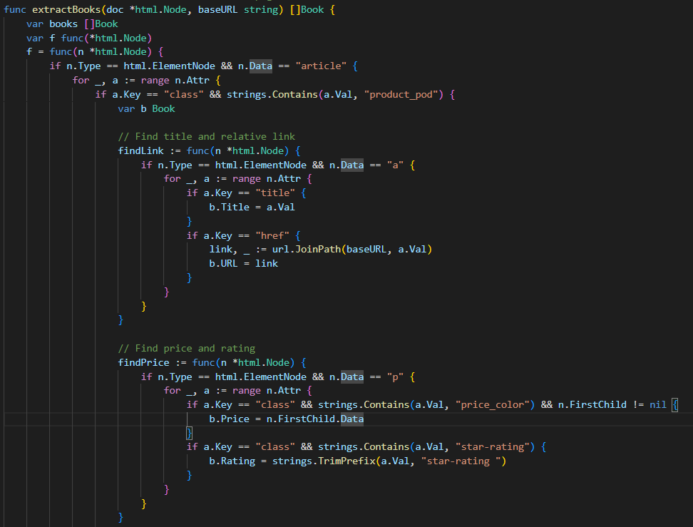
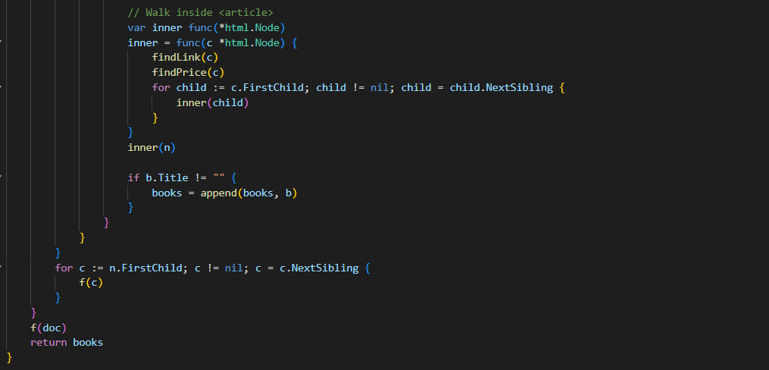
extractBooks Function
Purpose: Extracts detailed information about each book from the HTML document.
How it works:
- Walks through the HTML node tree recursively.
- Searches for <article> elements with the class "product_pod".
- Inside each article, it finds:
  - Title and URL from <a> tags
  - Price from <p> tags with class "price_color"
  - Rating from <p> tags with class "star-rating"
- Builds absolute URLs by combining the base URL with relative paths.
- Adds only complete book entries (those with a title) to the results list.
Key techniques include nested helper functions for clean extraction (findLink, findPrice, inner) and recursive tree traversal to ensure no book is missed.
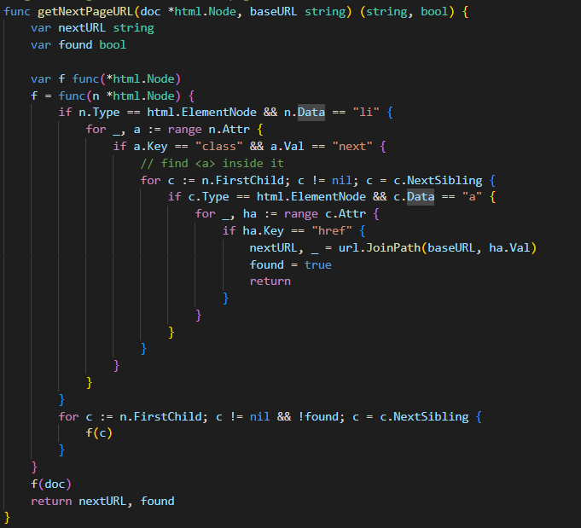
getNextPageURL Function
Purpose: Identifies the URL of the next page in a paginated catalog.
How it works:
- Looks for <li> elements with class "next".
- Finds the <a> tag inside the list item.
- Extracts the href attribute.
- Converts the relative path to an absolute URL.
- Returns the URL and a flag indicating whether a next page exists.
This function allows the scraper to continue automatically through multiple pages without hardcoding URLs.
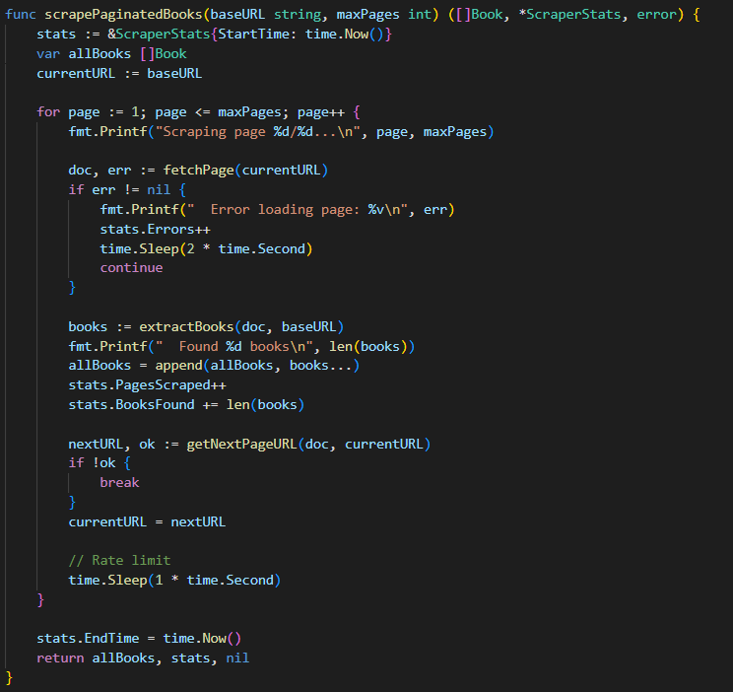
scrapePaginatedBooks Function
Purpose: Main scraping function that handles pagination.
How it works:
- Initializes statistics tracking with current time
- Starts with the base URL
- For each page (up to maxPages):
  - Fetches and parses the page
  - Extracts all books from the page
  - Updates statistics
  - Finds the next page URL
  - Implements rate limiting (1 second delay between requests)
- Stops if there's no next page or max pages reached
- Records end time and returns all books and statistics
Error handling:
- Logs errors but continues scraping other pages
- Implements a 2-second delay after errors to avoid overwhelming the server
- Increments error counter for reporting
Rate limiting: Sleeps for 1 second between pages to be respectful to the server.

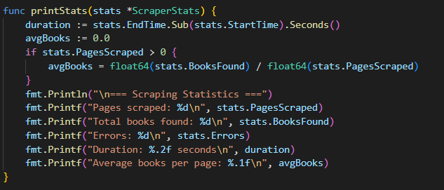
func printStats(stats *ScraperStats)
Purpose: Displays scraping statistics in a formatted report.
Metrics displayed:
- Total pages successfully scraped
- Total books found
- Number of errors encountered
- Total execution time
- Average books per page
Calculation: Computes average books per page and total duration for performance analysis.
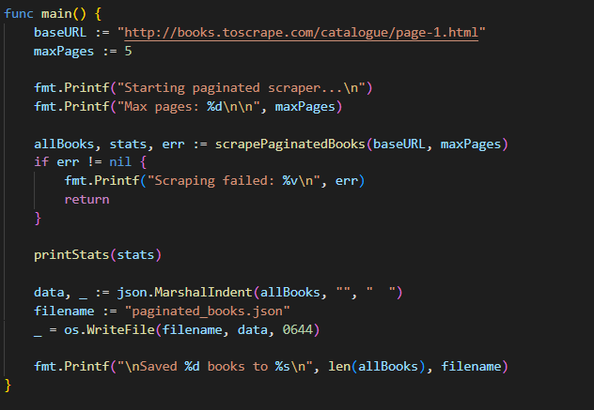
func main()
Purpose: Entry point that orchestrates the entire scraping process.
Execution flow:
- Defines configuration (base URL and max pages = 5)
- Prints initial configuration
- Calls scrapePaginatedBooks to perform the scraping
- Prints statistics report
- Converts results to pretty-printed JSON (with indentation)
- Saves JSON data to "paginated_books.json" file
- Prints confirmation message
Output:
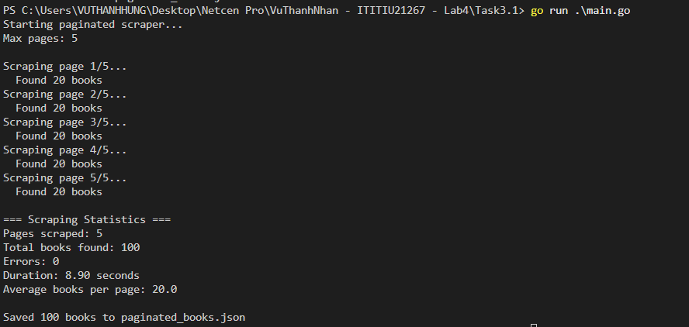

Task 4.1:
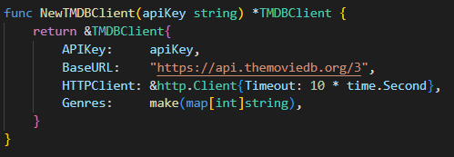
NewTMDBClient
Purpose: Constructor function that initializes the TMDB client.
- Sets 10-second timeout to prevent hanging requests
- Initializes empty genre map
- Returns pointer for efficient memory usage
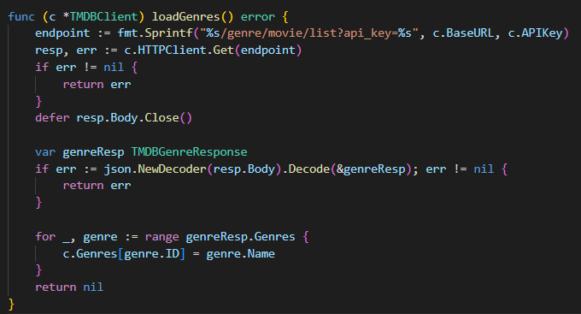
loadGenres
Purpose: Fetches genre list from TMDB and builds genre ID to name mapping.
- Makes GET request to genre endpoint
- Decodes JSON response directly from response body
- Populates genre map for later use
- Must be called before searching movies
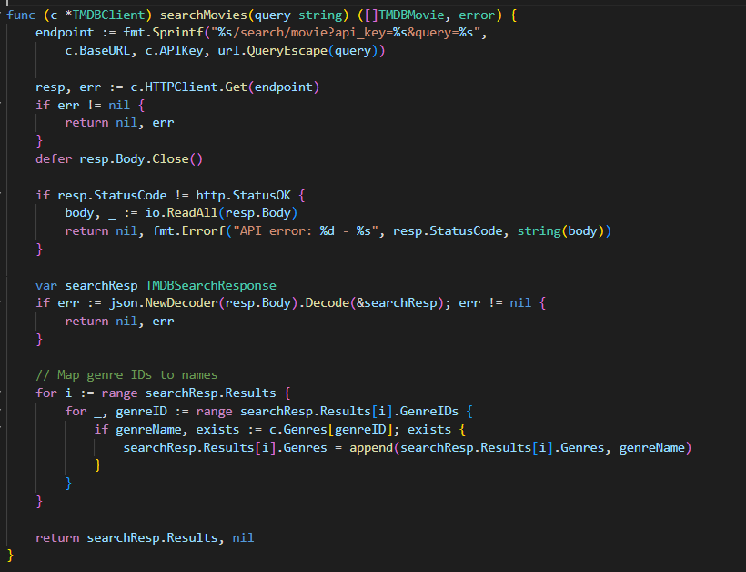
searchMovies
Purpose: Searches TMDB for movies matching query string.
- URL-escapes query to handle special characters
- Checks HTTP status code for errors
- Converts genre IDs to human-readable names
- Returns array of TMDBMovie structs
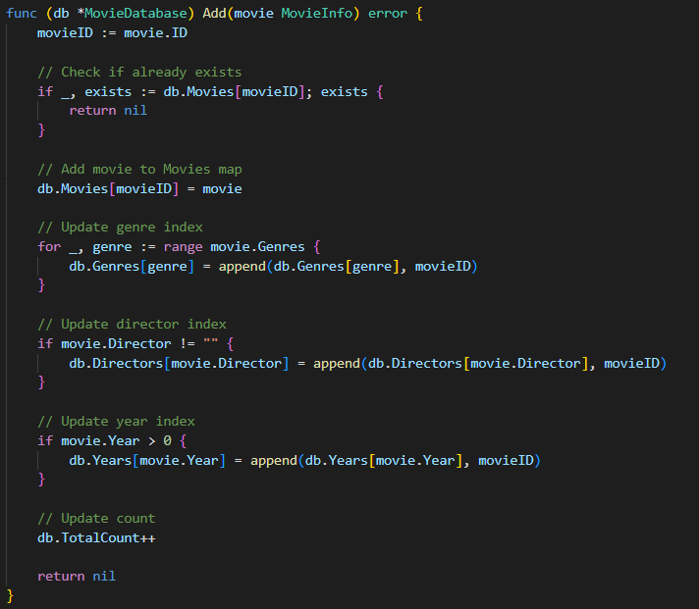
Add Method
Purpose: Adds a movie to database and updates all indexes.
- Prevents duplicates by checking if movie ID exists
- Updates all secondary indexes (genres, directors, years)
- Each index maps to a slice of movie IDs
- Increments total count

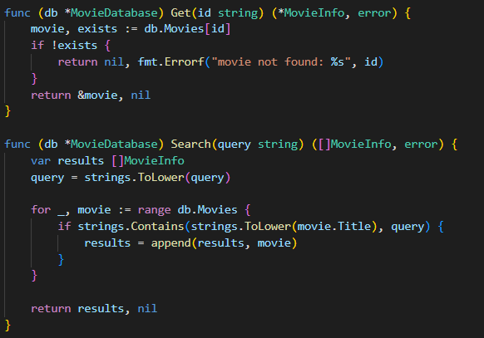
Get Method
Purpose: Retrieves a movie by ID (O(1) lookup).
- Direct map lookup - very fast
- Returns pointer to avoid copying large struct
- Returns error if movie doesn't exist
Search Method
Purpose: Searches movies by title (case-insensitive).
- Converts query to lowercase for case-insensitive matching
- Iterates through all movies (O(n) complexity)
- Uses substring matching with strings.Contains
- Returns all matching movies
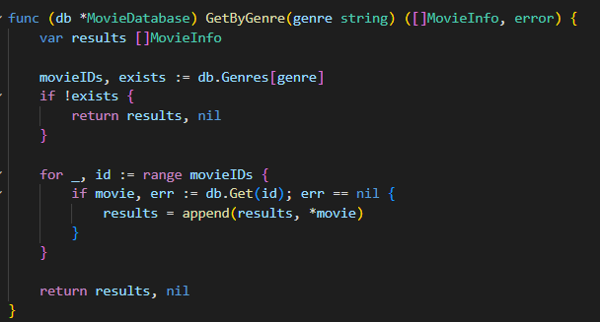
GetByGenre Method
Purpose: Gets all movies in a specific genre using index.
- Uses genre index for fast lookup (O(1) to find IDs)
- Iterates through movie IDs and retrieves full movie data
- Returns empty slice if genre doesn't exist
- Efficient: only looks up relevant movies
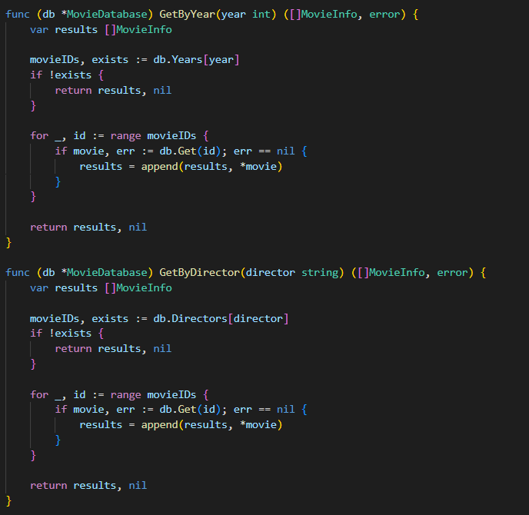
GetByYear & GetByDirector
Purpose: Query movies by year or director using respective indexes.
- Same pattern as GetByGenre
- Demonstrates index-based querying strategy
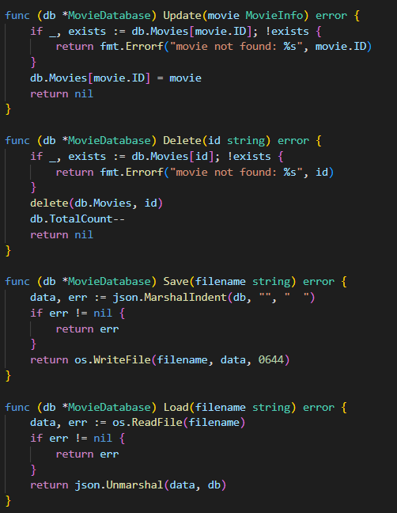
Update Method
Purpose: Updates an existing movie's information.
- Checks if movie exists first
- Simple map assignment to update
- Note: This simplified version doesn't rebuild indexes
Delete Method
Purpose: Removes a movie from the database.
- Validates movie exists before deleting
- Uses built-in delete() function
- Decrements total count
- Note: This simplified version doesn't clean up indexes
Save & Load Methods
Purpose: Persists database to disk and loads it back.
- Save: Converts database to pretty-printed JSON
- Load: Reads JSON file and unmarshals into database
- File permissions 0644: owner read/write, others read-only
- Enables data persistence between program runs
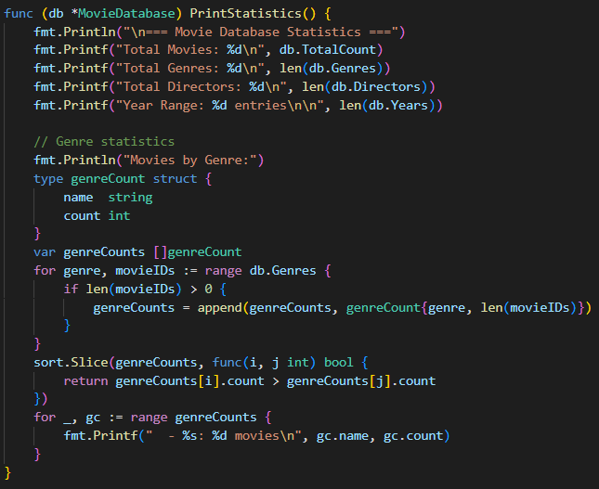
PrintStatistics Method
Purpose: Displays comprehensive database statistics.
- Shows totals for movies, genres, directors, years
- Sorts genres by movie count (descending)
- Uses anonymous struct for sorting pairs
- Provides overview of database composition
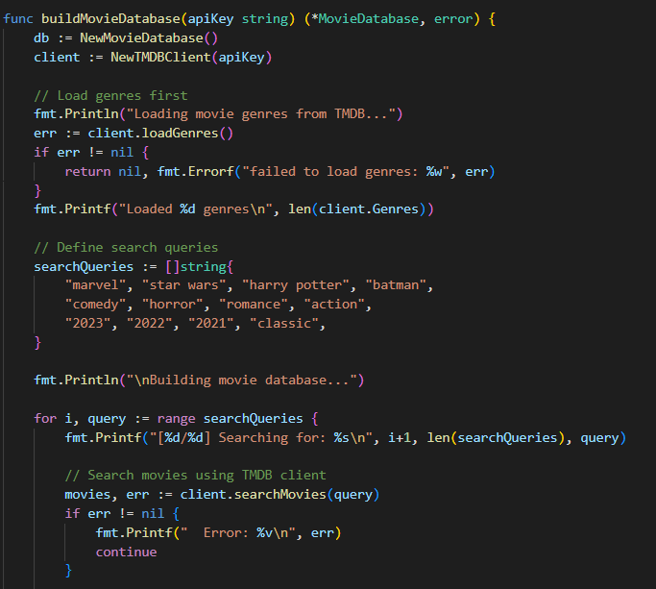
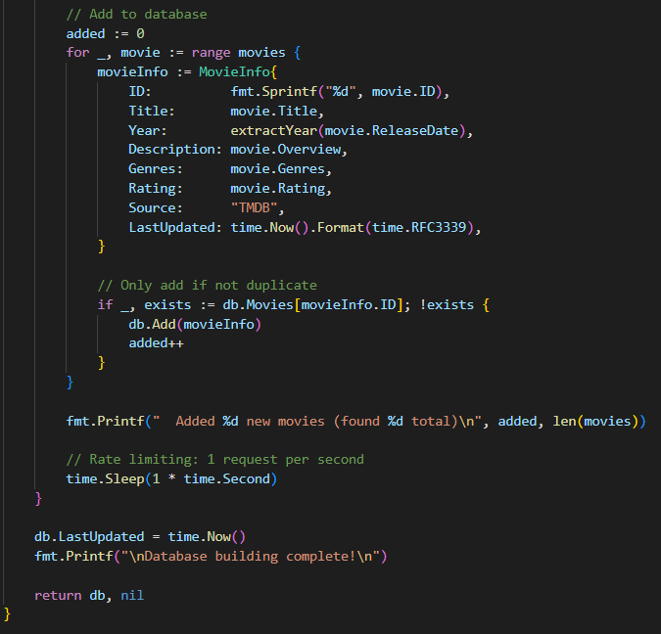
buildMovieDatabase Function
Purpose: Main pipeline that collects movies from TMDB.
- Step 1: Load genres (required for mapping genre IDs)
- Step 2: Define diverse search queries (12 categories)
- Step 3: Loop through queries with progress tracking
- Step 4: Transform TMDB data to MovieInfo format
- Step 5: Check for duplicates before adding
- Step 6: Rate limiting (1 second between requests)
- Step 7: Update timestamp when complete
Search Strategy:
- Franchises: "marvel", "star wars", "harry potter", "batman"
- Genres: "comedy", "horror", "romance", "action"
- Years: "2023", "2022", "2021", "classic"
- Target: 100+ unique movies
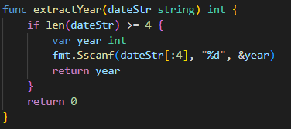
extractYear Helper Function
Purpose: Extracts year from TMDB date format ("YYYY-MM-DD").
- Takes first 4 characters (year part)
- Uses fmt.Sscanf to parse integer
- Returns 0 if date string is too short
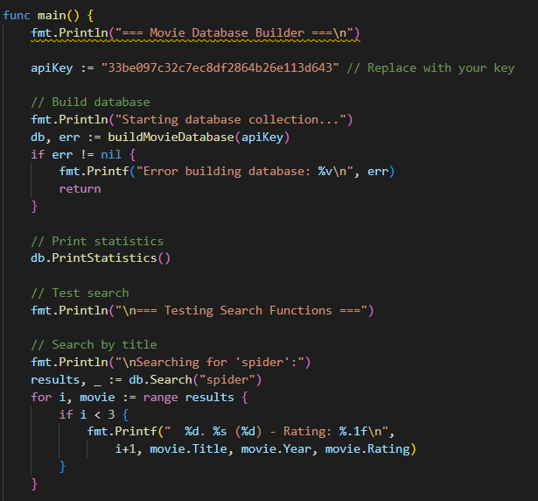
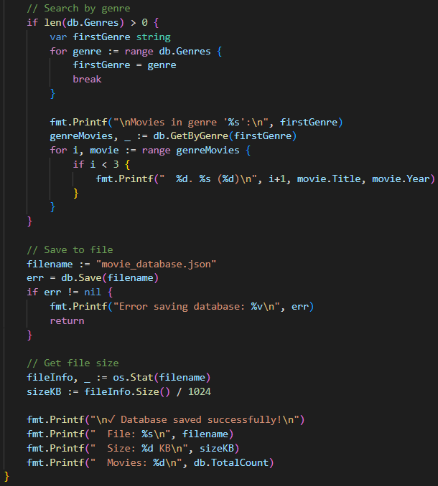
main Function
Purpose: Orchestrates the entire program flow.
Execution Steps:
- Build Database: Collect movies from TMDB API
- Display Statistics: Show database composition
- Test Searches: Demonstrate query functionality
  - Title search: "spider"
  - Genre search: First available genre
- Save Database: Persist to JSON file
- Show Results: Display file info and success message

